- Solve the proportion. Show your work.
$\frac{3}{x + 1}$ = $\frac{5}{11}$

$$3\left(11\right)=5(x+1)$$
$$33=5x+5$$
$$5x=33-5$$
$$5x=28$$
$$x=\frac{28}{5}$$
$$x=5.6$$

- The figures in each pair are similar. Find the value of each variable. Show your work.

- 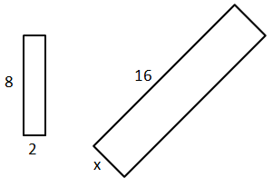

- 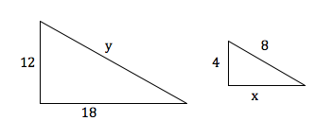

- Since the rectangles are similar, the ratio of each sides should be equal.
$$\frac{8}{16}=\frac{2}{x}$$
$$8x=32$$
$$x=4$$
- The two triangles are similar, the ratio of each sides should be equal.
$$\frac{12}{4}=\frac{18}{x}=\frac{y}{8}$$
$$\frac{12}{4}=\frac{18}{x}$$
$$x=18\left(\frac{4}{12}\right)$$
$$x=6$$
$$\frac{12}{4}=\frac{y}{8}$$
$$y=8\left(\frac{12}{4}\right)$$
$$y=24$$

- Determine whether the triangles are similar. If so, write a similarity statement and name the postulate or the theorem you used. If not, explain.

- 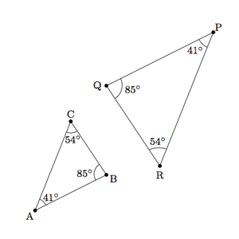

- 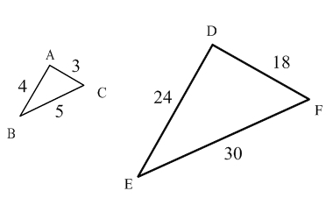

- Triangles are considered similar if two angles of one triangle are congruent two angles of the other triangle.
$$angle A=angle P=41°$$
$$angle B=angle Q=85°$$
$$angle C=angle R=54°$$
Therefore,
$$∆ABC is similar to ∆PQR$$

$$\frac{AB}{DE}=\frac{AC}{DF}=\frac{BC}{EF}$$
$$\frac{4}{24}=\frac{3}{18}=\frac{5}{30}=\frac{1}{6}$$
The two triangles are similar.

- Find the value of each variable for the right triangles. Make sure all answers are in reduced radical form. Show your work.

  - 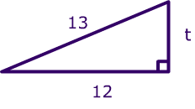
  - 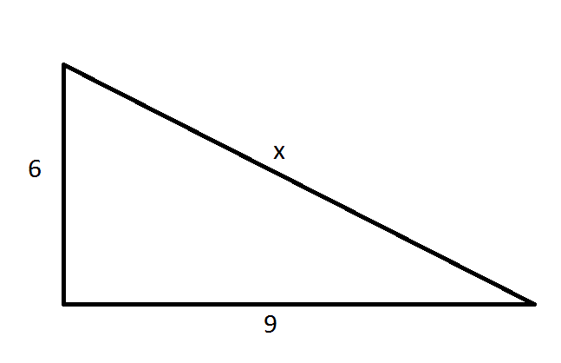

- $t^{2}={13}^{2}-{12}^{2}=169-144=25$
$$t=\sqrt{25}$$
$$t=5$$
- $x^{2}=6^{2}+9^{2}=36+81=117$
$$x=\sqrt{117}=3\sqrt{13}$$

- Given the following triangle side lengths, identify the triangle as acute, right or obtuse. Show your work.

  - 5 in, 6 in, 7 in

  - 18 in, 9 in, 12 in

$$c^{2}=a^{2}+b^{2}…………right angle$$
$$c^{2}<a^{2}+b^{2}…………acute angle$$
$$c^{2}>a^{2}+b^{2}…………obtuse angle$$
- Let
$$c=7…7^{2}=49$$
$$a=5…5^{2}=25$$
$$b=6…6^{2}=36$$
$$36+25=61>49$$
It is an acute triangle
- $c=18…{18}^{2}=324$
$$a=9…9^{2}=81$$
$$b=12…{12}^{2}=144$$
$$81+144=225<324$$
It is an obtuse triangle

- Find the missing value. Show your work. Round to the nearest hundredth.

  - 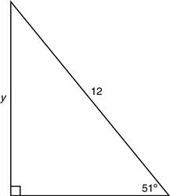

  - 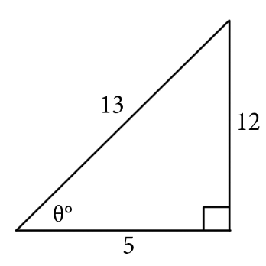

  - 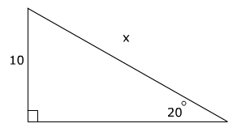

- $\sin\left(51°\right)=\frac{y}{12}$
$$y=12\sin{51°}$$
$$y=9.33$$
- $tanθ=\frac{12}{5}$
$$θ=\tan^{-1}\left(2.4\right)$$
$$θ=67.38°$$
- $\sin\left(20°\right)=\frac{10}{x}$
$$x=\frac{10}{sin⁡(20°)}=29.24$$

- Given the vertices of ∆ABC are A (2,-5), B (-4,6) and C (3,1), find the vertices following each of the transformations FROM THE ORIGINAL vertices:

  - R_{x = 3}

  - T_{<3,-6>}

  - r_{(90◦, o)}

- Reflecting over the line x=3
A’ (2+2, -5) = (4, -5)
B’ (-4+14, 6)=(10,6)
C’ (3+0, 1)=(3,1)
- Translation (3, -6)-Moving x value 3 units to the right and y value 6 units downwards
A’(2+3,-5-6)=(5,-11)
B’(-4+3,6-6)=(-1,0)
C’(3+3,1-6)=(6,-5)
- Rotating in a clockwise direction.
A’(-5,-2)
B’(6,4)
C’(1,-3)

- Find the congruence transformation that maps ∆ABC to ∆A’B’C’. Explain.
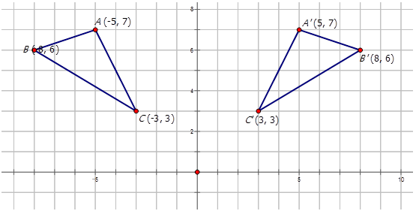
The triangle is reflected over the y-axis. The y values remain unchanged while the x values change the sign.

- Find the area of each figure to the nearest tenth.

  - 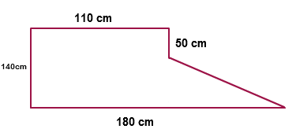
$$Area=\left(110×140\right)+\frac{1}{2}×\left(140-50\right)\left(180-110\right)$$
$$Area=15400+0.5\left(90\right)\left(70\right)=18550 {cm}^{2}$$
  - 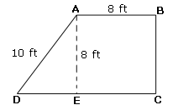

$$DE=\sqrt{{10}^{2}-8^{2}}=\sqrt{36}=6$$
$Area=8×8+0.5\left(6\right)\left(8\right)$=88 ${cm}^{2}$

- Find the measure of both arc AB and arc APB, where <APB = 108◦. Please be sure to show your steps.
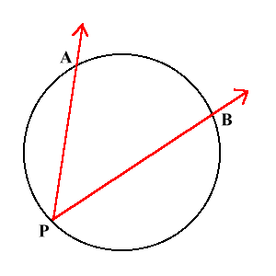
Let O be the center of the circle. Angle subtended by an arc at the center of a circle is double the angle subtended at any point on the circle.$angle AOB=2\left(angle APB\right)=2\left(108\right)=216$

- Find the area of a regular Octagon with side lengths 5in. Round your answer to the nearest tenth.
Area of an octagon=$2a^{2}\left(1+\sqrt{2}\right)=2×5^{2}\left(1+\sqrt{2}\right)=120.7 {cm}^{2}$

- Find the surface area of each figure to the nearest tenth.

  - 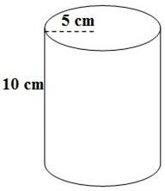 b. 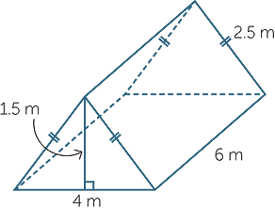

- Surface area=$2πr^{2}+2πrh=2π\left(5^{2}\right)+2π\left(5\right)\left(10\right)=471 {cm}^{2}$.
- Surface area=$l×w+0.5\left(base\right)\left(height\right)+length×hypotenuse×2$
$$2×6×4+0.5×4×1.5+6×2.5×2=81 {cm}^{2}$$
  - What is a real-world example or use of surface area?
You can use the surface are of a rectangular tin to determine the amount of paint needed.

- Find the surface area of each figure to the nearest tenth.

  - 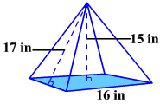

  - 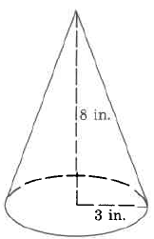

- $Perimeter of the square base,P=4\left(16\right)=64 in$
$$Area of the base, A=16^{2}=256 {in}^{2}$$
$$Total surface area=0.5×64×17+256=800 {in}^{2}$$
- $Surface area=πr^{2}+πrl$
$$slant length, l=\sqrt{8^{2}+3^{2}}=8.544 in$$
$$Surface area=π{×3}^{2}+π×3×8.544=108.8 {in}^{2}$$

- Find the volume of each figure to the nearest tenth.

  - 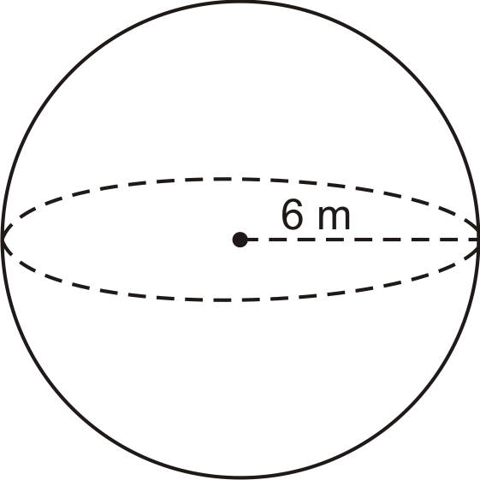

  - 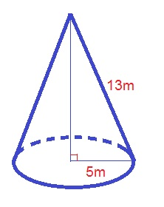

  - 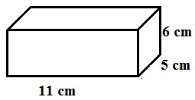

- $V=\frac{4}{3}πr^{3}$
$$V=\frac{4}{3}π\left(6^{3}\right)=904.8 m^{3}$$
- $V=\frac{1}{3}πr^{2}h$
$$h=\sqrt{{13}^{2}-5^{2}}=12 m$$
$$V=\frac{1}{3}π{(5)}^{2}×12=314.2 m^{3}$$
- $V=lwh=11×5×6=330 {cm}^{3}$

- Find the center and radius, then write the standard equation of each circle

  - 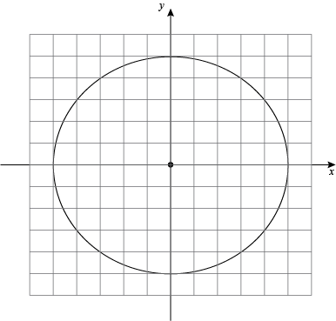
  - 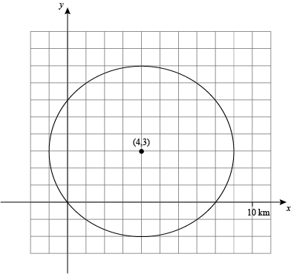

  - 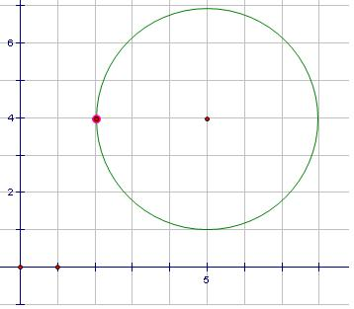

- $Center=\left(0,0\right), radius=5$
$$Equation…x^{2}+y^{2}=25$$
- $Center=\left(5,4\right), radius=3$
$$Equation…{\left(x-5\right)}^{2}+{\left(y-4\right)}^{2}=9$$
- $Center=\left(4,3\right), radius=5$
$$Equation…{\left(x-4\right)}^{2}+{\left(y-3\right)}^{2}=25$$

- Solve for x

  - 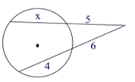

  - 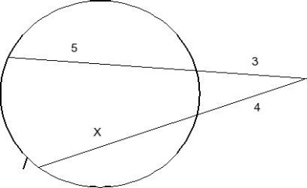

- $5×\left(5+x\right)=6×10$
$$25+5x=60$$
$$5x=60-25$$
$$5x=35$$
$$x=7$$
- $3×8=4×\left(4+x\right)$
$$24=16+4x$$
$$4x=24-16$$
$$4x=8$$
$$x=2$$

- Evaluate

  - 6!

  - ₈P₅

  - ₁₂C₄

- $6!=6×5×4×3×2×1=720$
- $n=8,r=5, P=\frac{n!}{\left(n-r\right)!}$
$$=\frac{8×7×6×5×4×3×2}{3×2}=6720$$
- $n=12,r=4, C=\frac{n!}{r!\left(n-r\right)!}$
$$=\frac{12×11×10×9×8×7×6×5×4×3×2}{\left(4×3×2\right)\left(8×7×6×5×4×3×2\right)}=495$$

- Use the spinner to find each theoretical probability
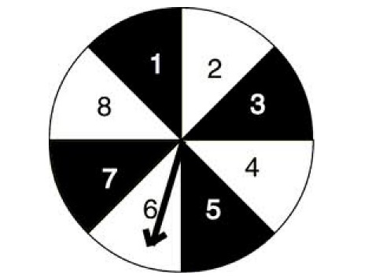
  - P (a number no more than 5)
A number no more than 5=1,2,3,4,5
$Probability=\frac{5}{8}$
  - P (an even number)
Even number=2,4,6,8
$$Probability=\frac{4}{8}=\frac{1}{2}$$
  - P (a number less than 3)
A number less than 3=1,2
$$Probability=\frac{2}{8}=\frac{1}{4}$$

- You roll two standard number cubes. What is the probability that the sum is odd,
given than one of the number cubes shows a 4?
Possibilities= (1,4), (3,4), (5,4), (4,1), (4,3), (4,5)
The total outcomes=36
$$Probability=\frac{6}{36}=\frac{1}{6}$$

- What is the area of the figure:

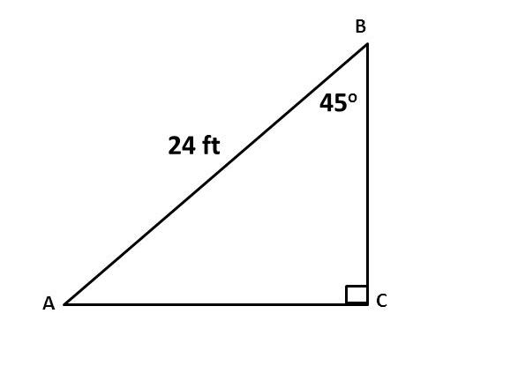
$$sin45°=\frac{AC}{24}$$
$$AC=24sin45°=16.97 ft$$
$$cos45°=\frac{BC}{24}$$
$$BC=24cos45°=16.97 ft$$
$$Area=\frac{1}{2}\left(AC\right)\left(BC\right)=0.5(16.97)(16.97=143.9905 {ft}^{2})$$

